|  |
| --- |
|  |
| The Documentation |
| [Type the document subtitle] |
|  |
| **[Your Name]** |
| **[Pick the date]** |

[Type the abstract of the document here. The abstract is typically a short summary of the contents of the document. Type the abstract of the document here. The abstract is typically a short summary of the contents of the document.]

Table of Contents

[To update the table of contents, right click the message below and select Update Field (F9 on PC, ⌥⌘U on Mac).]

**No table of contents entries found.**

1. Pages
   1. Page Tree

Home  
 Page 1  
 Page 2  
 Page 3

* 1. Home
     1. User Interface

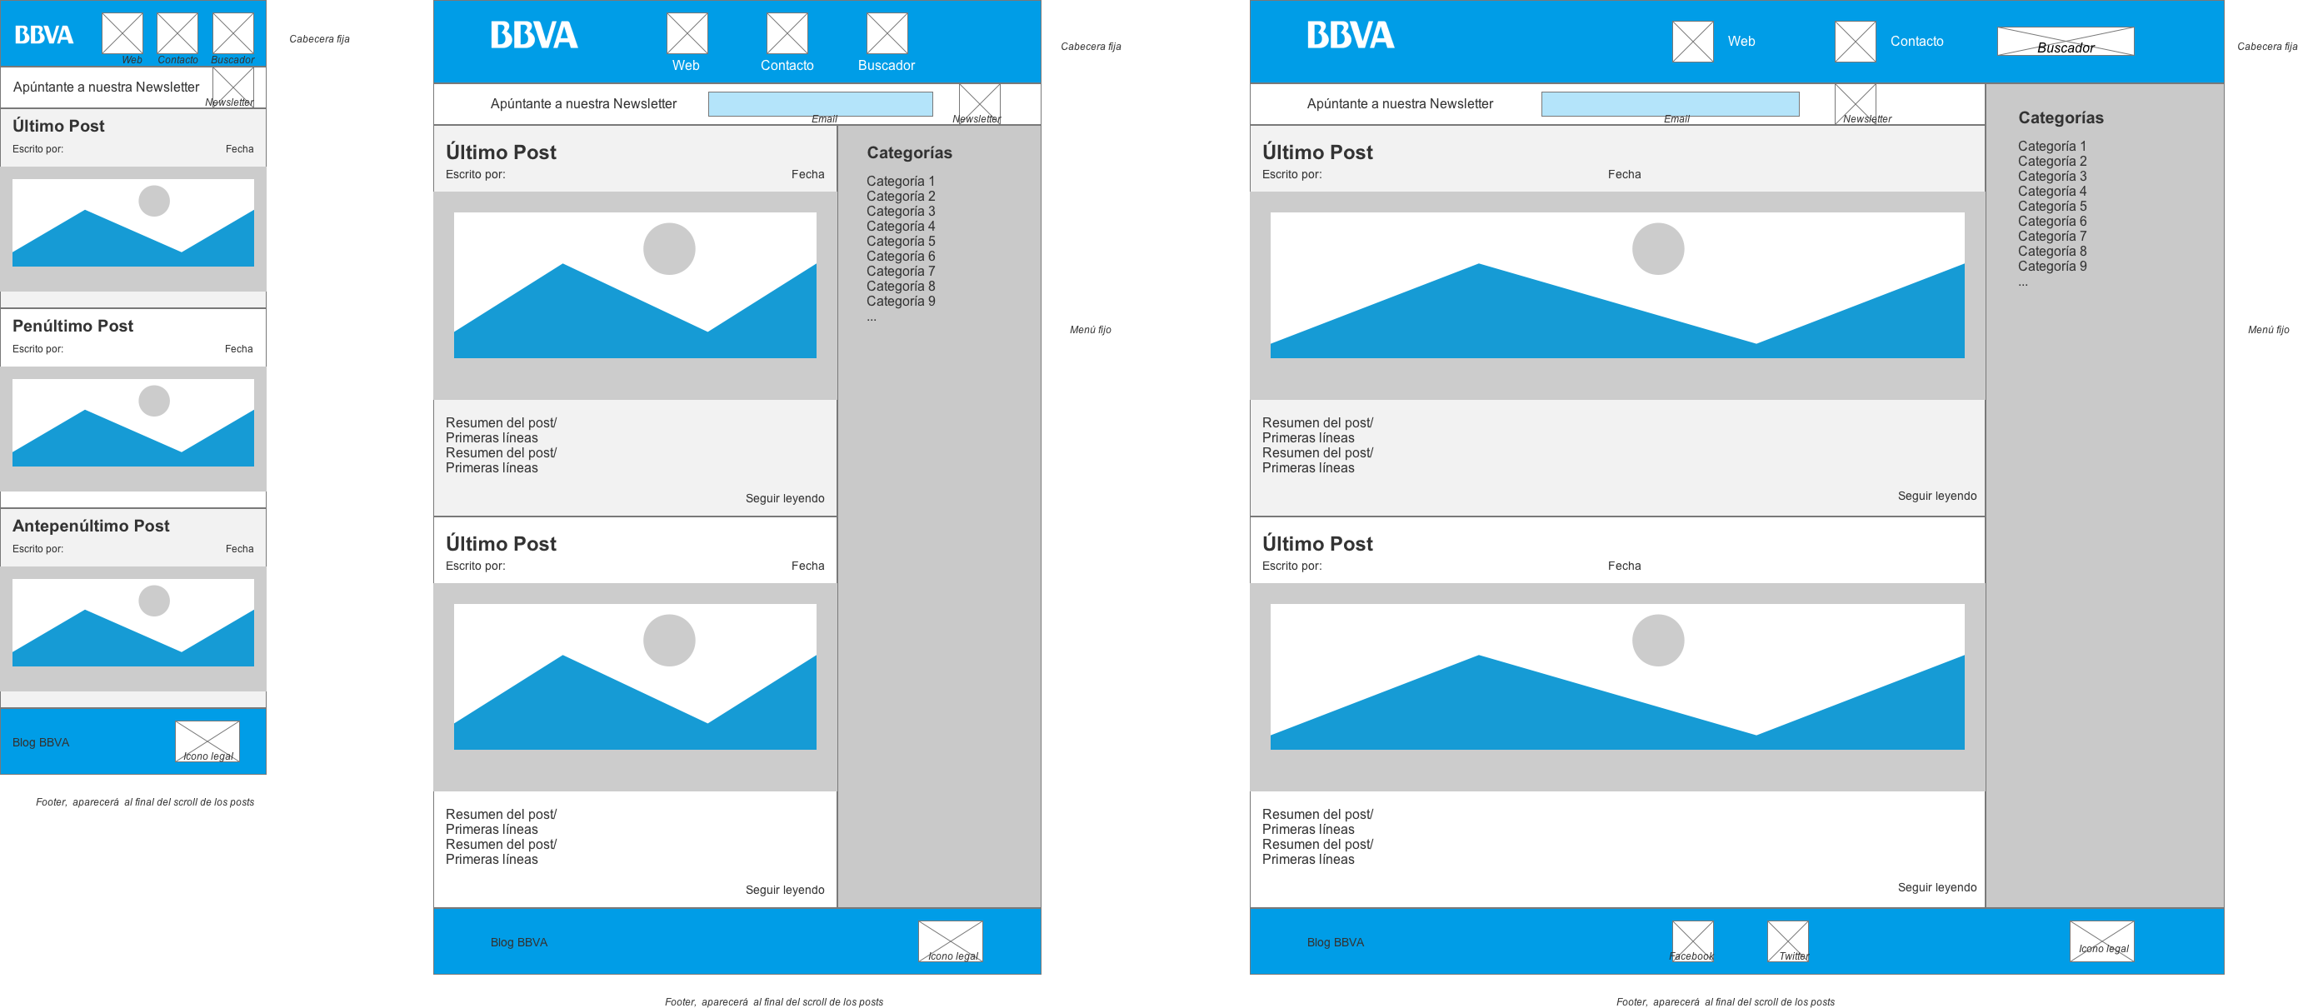

* 1. Page 1
  2. Page 2
  3. Page 3